**Note:** All the questions are implemented in the form of functions. Use the main() function to call the function you write and output the return value of the function

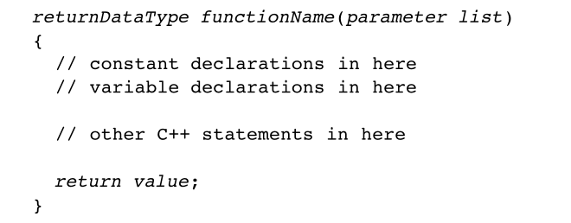

1. Given a string and length of the string n, find the first non-repeating character in it and return its index. If it doesn't exist, return -1.

**Example1:**

**Input**:

8

leetcode

**Output**： 0.

**Example2:**

**Input**:

13

sloveleetcdes

**Output**： 2.

**Constraints:** String length less than 500

**Note:**

1. You may assume the string contains only lowercase English letters.
2. More Examples. If the input string is “GeeksforGeeks”, then the output should be ‘f’ and if the input string is “GeeksQuiz”, then the output should be ‘G’.



1. A perfect number is a positive integer that is equal to the sum of its positive divisors, excluding the number itself. A divisor of an integer x is an integer that can divide x evenly.

Given an integer n, return true if n is a perfect number, otherwise return false.

**Example 1:**

**Input**: 28

**Output**: true

**Explanation**: 28 = 1 + 2 + 4 + 7 + 14

1, 2, 4, 7, and 14 are all divisors of 28.

**Example 2:**

**Input**: num = 496

**Output**: true

**Example 3:**

**Input**: num = 2

**Output**: false

**Constraints:**1 <= num <= 108

1. Enter n pairs of integers from the keyboard to find the maximum sum of all odd numbers between these pairs of integers. The first integer is n, followed by n pairs of integers. It is required to calculate the sum of all odd numbers between a pair of integers min and max (including min and max) by function. If min > max, the return value of the function is 0.

**Example 1:**

**Input**:

3

10 20 17 31 40 45

**Output**:192

**Constraints:** n <=100

1. Input 2 positive integers a and n, calculate the sum of a+aa+aaa+aa…a+....,for example, input 2 and 3, calculate 2+22+222, output 246.

**Example 1:**

**Input**:2 3

**Output**:246

(Optional)

5. The first input parameter is n, The next n numbers represent the daily stock price. You want to maximize your profit by choosing a single day to buy one stock and choosing a different day in the future to sell that stock.

Return the maximum profit you can achieve from this transaction. If you cannot achieve any profit, return 0.

**Example 1:**

**Input**:

6

7 1 5 3 6 4

**Output**:5

**Explanation**: Buy on day 2 (price = 1) and sell on day 5 (price = 6), profit = 6-1 = 5.

Note that buying on day 2 and selling on day 1 is not allowed because you must buy before you sell.

**Example 2:**

**Input**:

5

7 6 4 3 1

**Output**:0

**Explanation**: In this case, no transactions are done and the max profit = 0.

**Constraints:1 <= n <= 10000**